FORM ACCL-PC3
ACCL AIR DISTRIBUTION PROCEDURE AND CHECKLIST

AHRI CERTIFICATION PROGRAM FOR AIR-COOLED WATER-CHILLING PACKAGES USING THE VAPOR COMPRESSION CYCLE
ACCL Air Distribution: Sketch Page
ACCL Participant: __________ Date of Test: __________ Witness Test Number: __________
Test Point: __________
*******************************************************************************************************************************

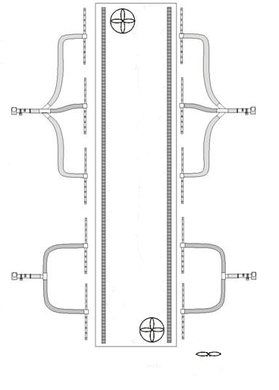
*************************************************************************************************** SAMPLE SKETCH
T/P#6____
R/C#6____

T/P#7____
R/C#7____

A/P#3____

T/P#8____
R/C#8____

T/P#9____
R/C#9____

T/P#10____
R/C#10____

A/P#4____

Mixing Fan

Test
Chiller

T/P#1____
R/C#1____

T/P#2____
R/C#2____

T/P#3____
R/C#3____

T/P#4____
R/C#4____

T/P#5____
R/C#5____

A/P#2____

A/P#1____

Sketch Requirements:
- Show location of Test Chiller
- Show locations of all Sampling Trees/Thermopiles (T/P)
- Show connections of Sampling Trees to Aspirating Psychrometers (A/P)
- Show locations of mixing fans (if used) and direction of air flow
- Label all components and provide space for recording values
T/P#6____
R/C#6____

ACCL Air Distribution: Checklist (reference Appendix E of AHRI Standard 550/590 - 2011(I-P) or AHRI Standard 550/590 (SI))
- Make several copies of the Sketch page and the Checklist and staple one to each other, in order to have a set of each of the pages for each of the Full load and Part load tests
- Hand-sketch the top view of chiller and associated air temperature measurement equipment (on Sketch page)
- Confirm that the Air Samplers are installed around the test chiller, as per Appendix E ______(initial)
- Confirm that A/Ps are installed correctly and operational, as per Appendix E ______(initial)
- Confirm that mixing fans (if used) are positioned correctly, as per Appendix E ______(initial)
- Confirm that each of the T/P values are within ±0.5 °F [±0.28°C] of ambient prior to start of chiller______(initial)
- Start the chiller and Facility air systems. Once the appropriate test conditions have been reached and are stable, record temperature values (on Sketch page) as simultaneously as possible prior to the start of data collection
- Transfer temperature values to this sheet
- Calculate and Record Mean Air Dry-Bulb Temperature (MADBT) ______(value)
- Confirm that each of the A/P values are within ±2.00 °F [±1.11°C] (for units </= 200 tons_{R})
or ±3.00 °F [±1.67°C] (for units >200 tons_{R} [703 kW]) of the MADBT ______(initial)
- Confirm that each of the T/P values are within ±1.50 °F [±0.83°C] of each A/P ______(initial)
- Confirm that each of the R/C values are within ±5.0 °F [±2.78°C] of the MADBT ______(initial)
- Once all Air Distribution checks are validated, data collection may begin
Notes:
- Mean Air Dry-Bulb Temperature = Average of all A/P-recorded values
- A/P = Aspirating Psychrometer
- T/P = Thermopile (each Air Sampler contains a Thermopile)
- R/C = Recirculating Thermocouple (each Air Sampler contains a Recirculating Thermocouple)

